# **Name: Abdurrahman Qureshi**

# **Roll No: 242466**

Practical No: 1

Date Of Performance: 11/07/2025

Aim: To clone a GitHub repository, install dependencies, run the application on a local server, and deploy it to Vercel with environment variables.

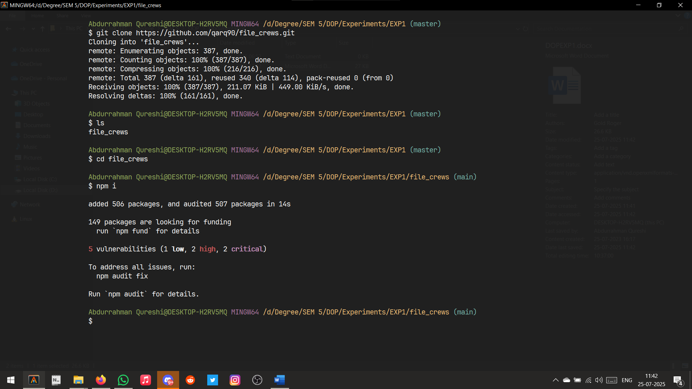

Cloning a Repository and installing dependencies

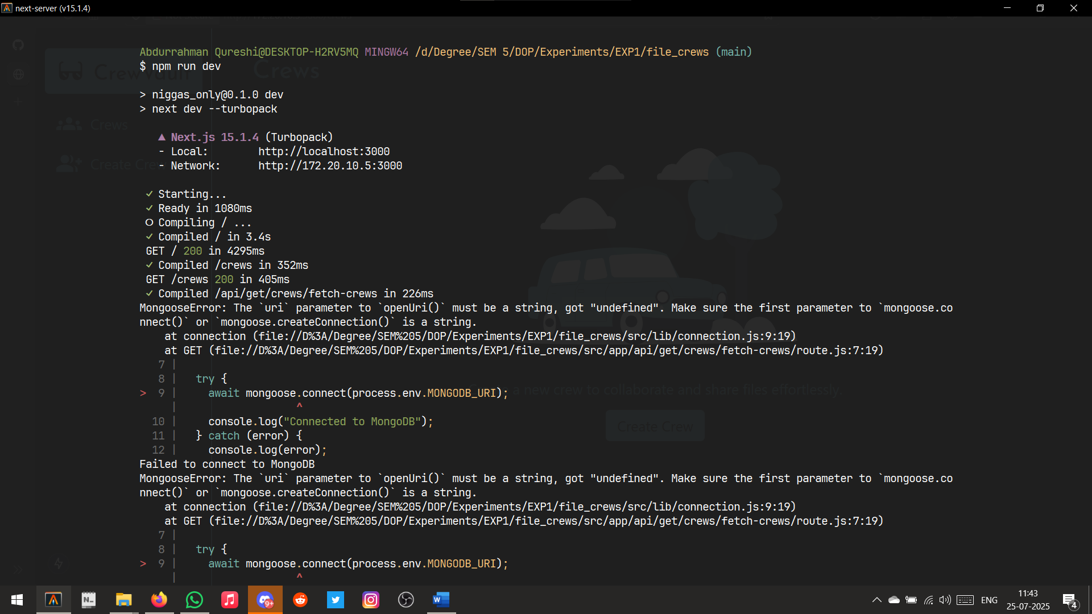

Installing Dependencies

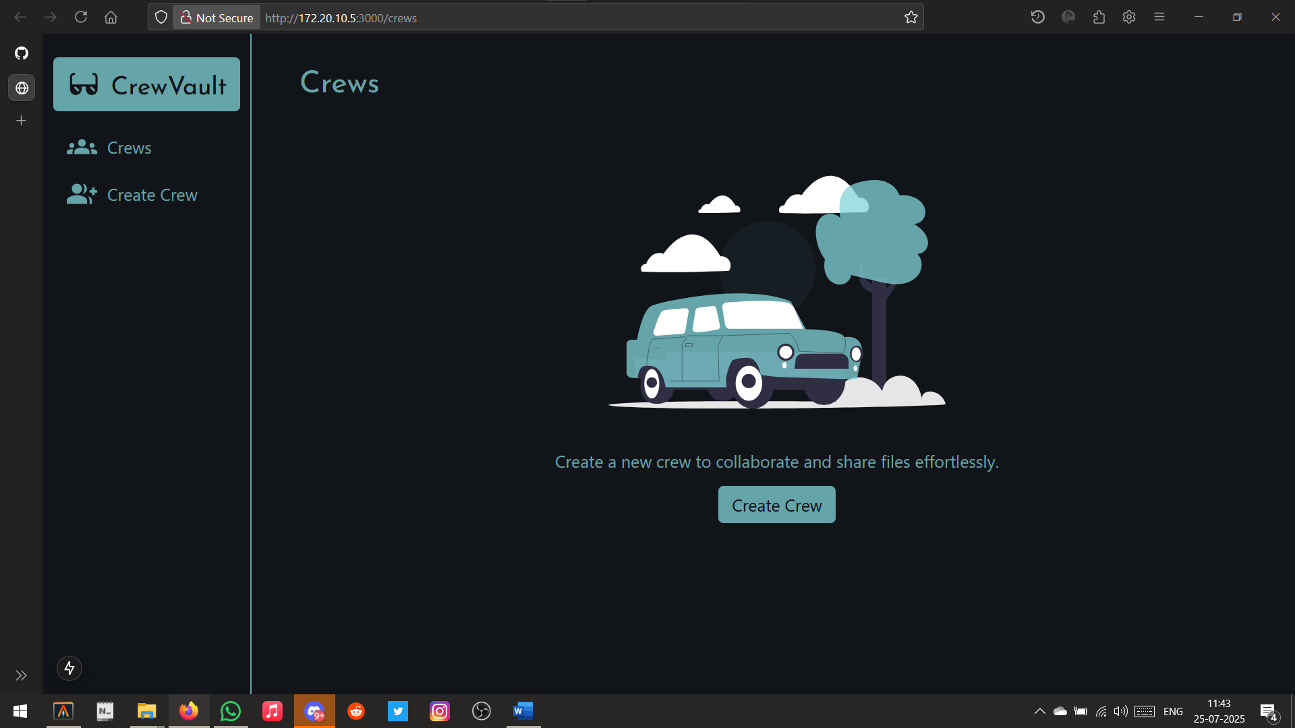

Running on local server

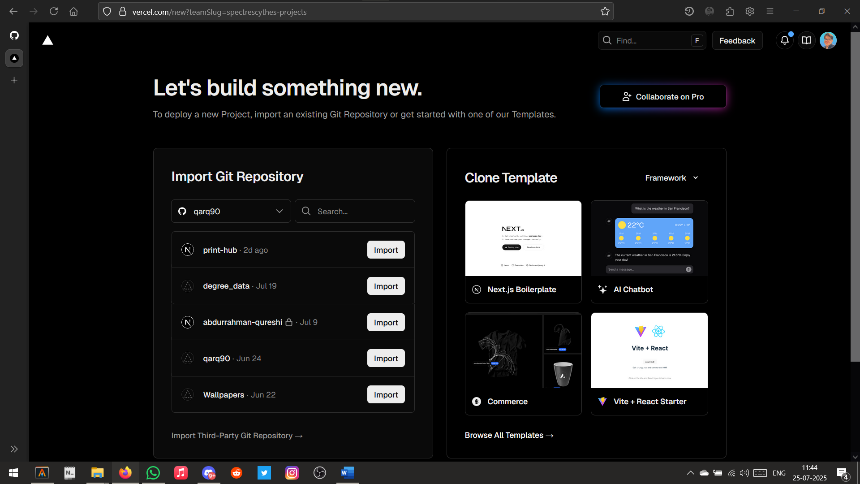

Importing the Git Repository on vercel

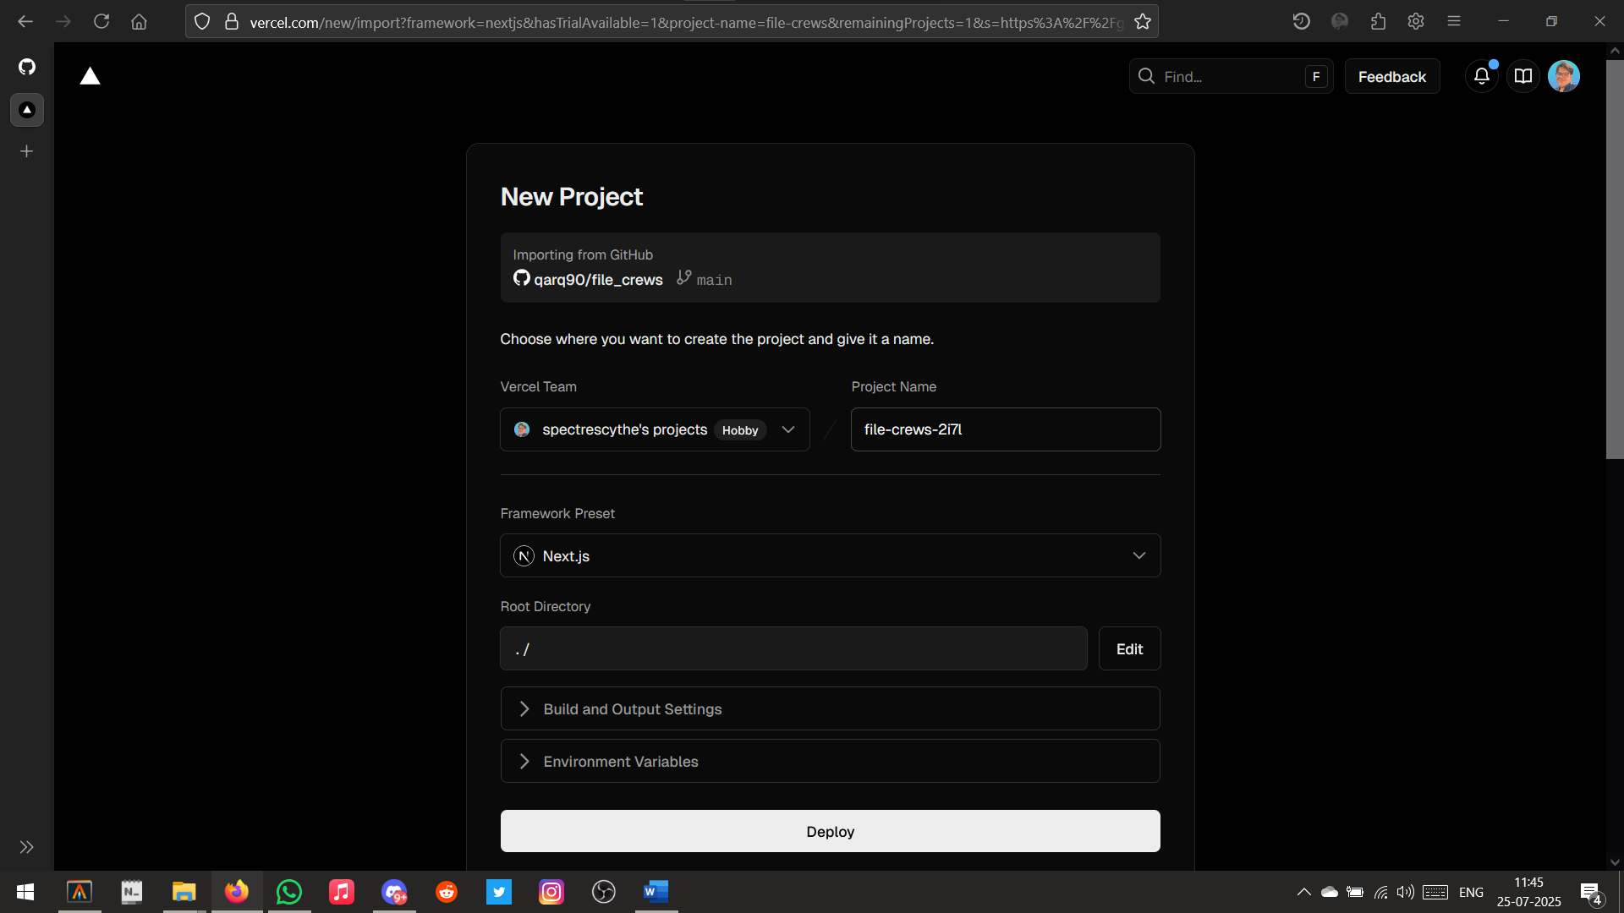

Importing ‘file_crews’

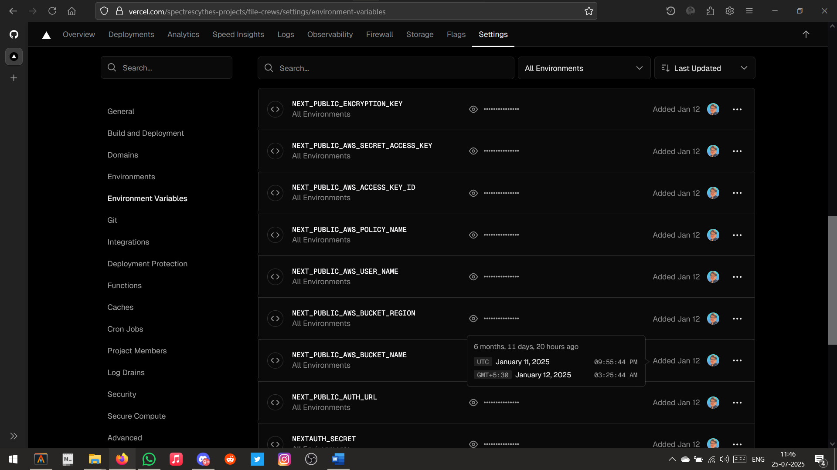Setting up Environment Variables

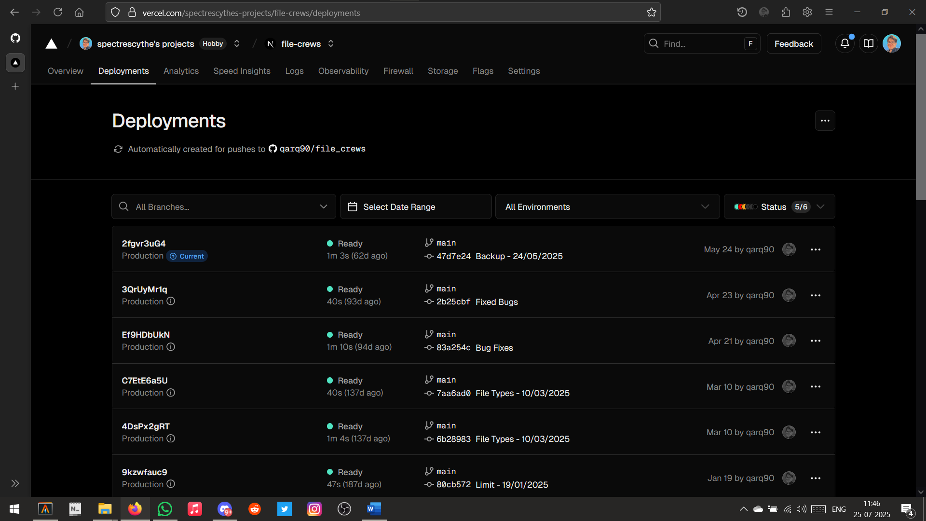

Successfully Deployed ‘file_crews’

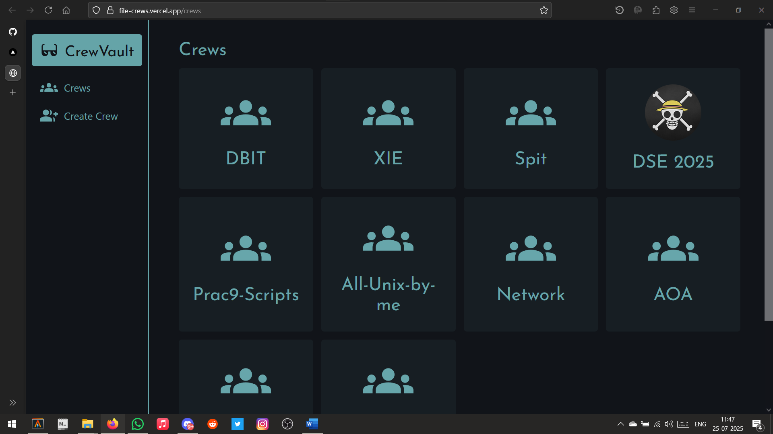

Opened on hosted URL

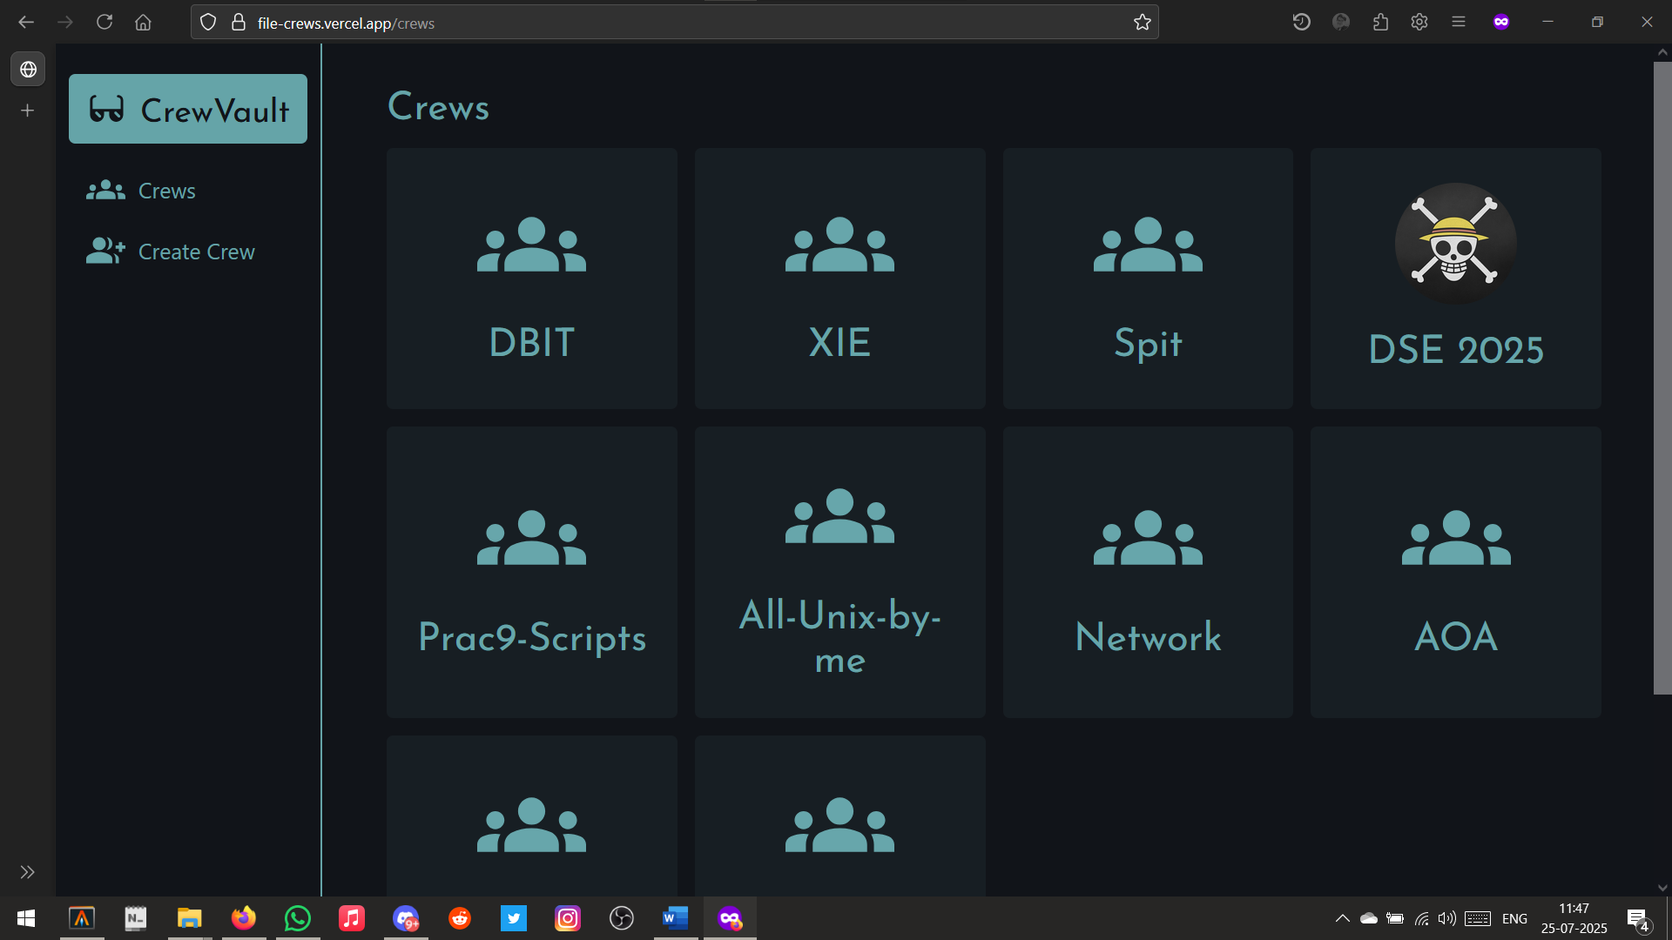

Opened on Incognito Tab